**JACart Circuit Manual:**

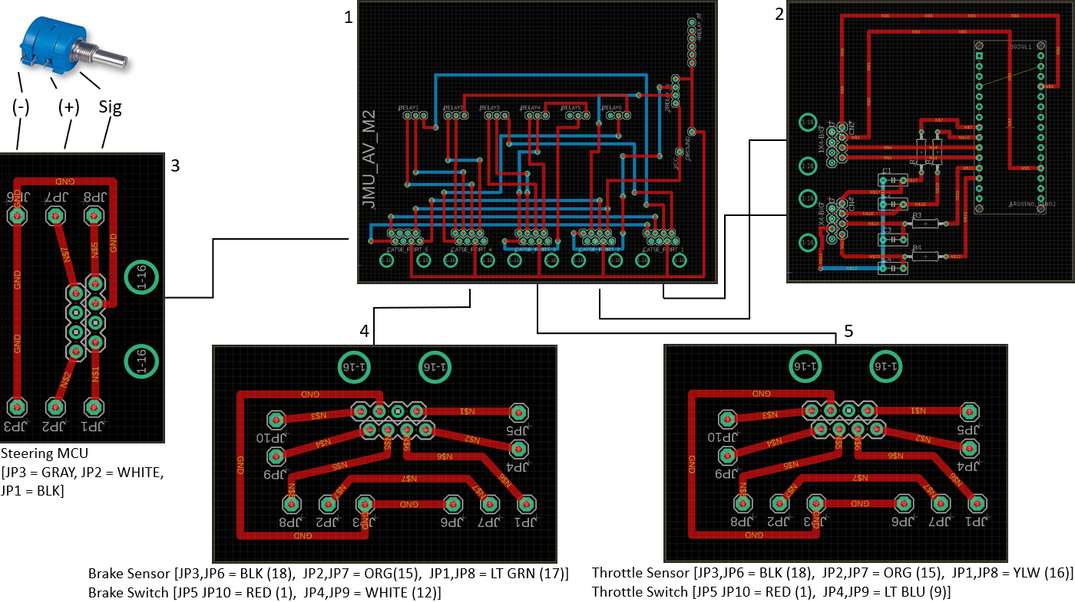This manual will review steering, brake, throttle circuits used in the golf cart as of April 2020. Below is an overview of the electronic components involved. A description of each individual board is detailed in subsequent paragraphs.

**Figure 1**: Complete view of steering, brake, and throttle components in the golf cart.

**Overview:**

The (INSERT GOLF CART NAME HERE) is selected by the team for this project extension from and earlier model because (WHY DID WE SELECT THIS MODEL?). For the primary controls, i.e., steering, braking and throttle, five individual boards are used: 1 - Motherboard, 2 - Arduino Board, 3 – Steering Board, 4 - Brake Board, 5 - Throttle Board. Each board has its own individual task when in Autonomous Mode.

Each board in **Figure 1** was produced by using Eagle Cad. The board view is the only thing visible in this diagram as it is an overview. The solid lines interconnecting each board to the Motherboard represent CAT5e Ethernet cables.

The components needed to exactly replicate this design requires the following:

* Potentiometer (1 required)
  + <https://www.digikey.com/product-detail/en/bourns-inc/3590S-2-103L/3590S-2-103L-ND/1088586>
* 2-Channel Relay (1 required)
  + <https://www.sainsmart.com/products/2-channel-5v-relay-module>
* 4-Channel Relay (1 required)
  + <https://www.sainsmart.com/products/4-channel-5v-relay-module>
* CAT5e Module (10 required)
  + <https://www.digikey.com/product-detail/en/assmann-wsw-components/A-2004-2-4-LP-S-R/AE10388-ND/2183639>
* Wire to Block Terminal (4 – Two Piece, 6 – Three Piece)
  + <https://www.digikey.com/product-detail/en/on-shore-technology-inc/OSTTC022162/ED2609-ND/614558>
* Arduino Nano (1 required)
  + <https://www.arduino.cc/en/pmwiki.php?n=Main/ArduinoBoardNano>
* (###) Resistor (4 required)
  + Link
* (###) Capacitor (4 required)
  + Link

The placement of all these components are discussed in their respective sections in this manual. Text boxes below the steering board, brake board, and throttle board have the specific wires that provide input needed for proper operation. The names of corresponding modules are labeled first, followed by their designated 36-pin MCU connector wire color and pin number connection.

**Figure 2** illustrates the main wiring diagram for the golf cart. There are arrows identifying the four specific connection points used for the brake and throttle boards.

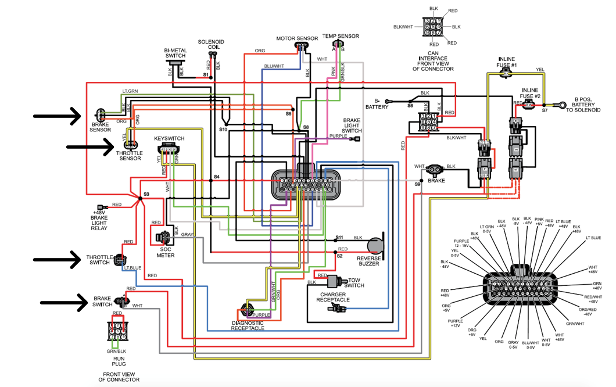

**Figure 2**: Main Wiring Harness Diagram of the 36-pin connector from the Golf Cart MCU

**1 – Motherboard:**

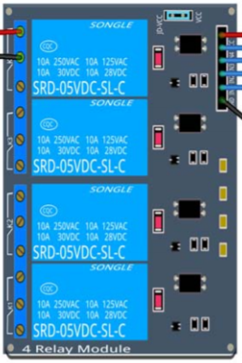

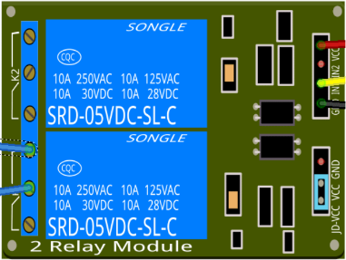

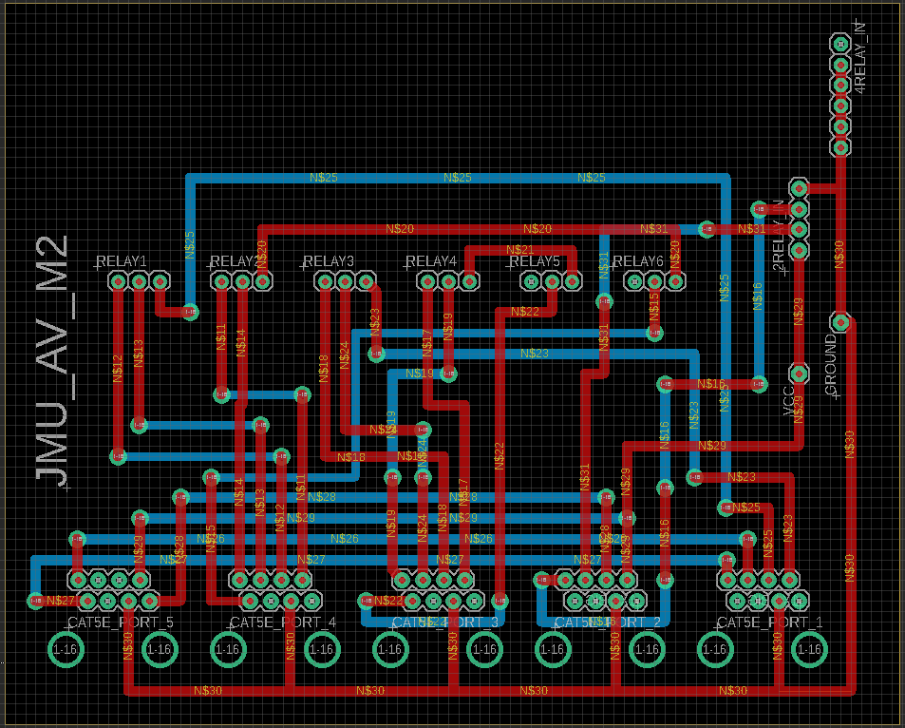

}

**Figure 3**: Enlarged Board View (Eagle Cad) of Motherboard and components.

The Motherboard is the main hub for the golf cart’s electronic components. The materials needed to assemble this component completely are: 2-Channel Relay, 4-Channel Relay, 5 Cat5e Modules. The relays will be wired as shown in **Figure 3**. The 5 Cat5e modules will be placed in the bottom portion of the board. The silkscreen layer of the board has multiple labels named, “CAT5E_PORT#”. These numbers correspond to the boards that we designed as a prototype. Do not pay too much attention to these numbers since the boards each of these ports are assigned to are labeled properly in **Figure 1**. The upper portion of the board is divided into six segments of 3 wires for each individual relay to make the soldering between board and relays much smoother. The wiring diagram of this board can be seen below in order to better understand.

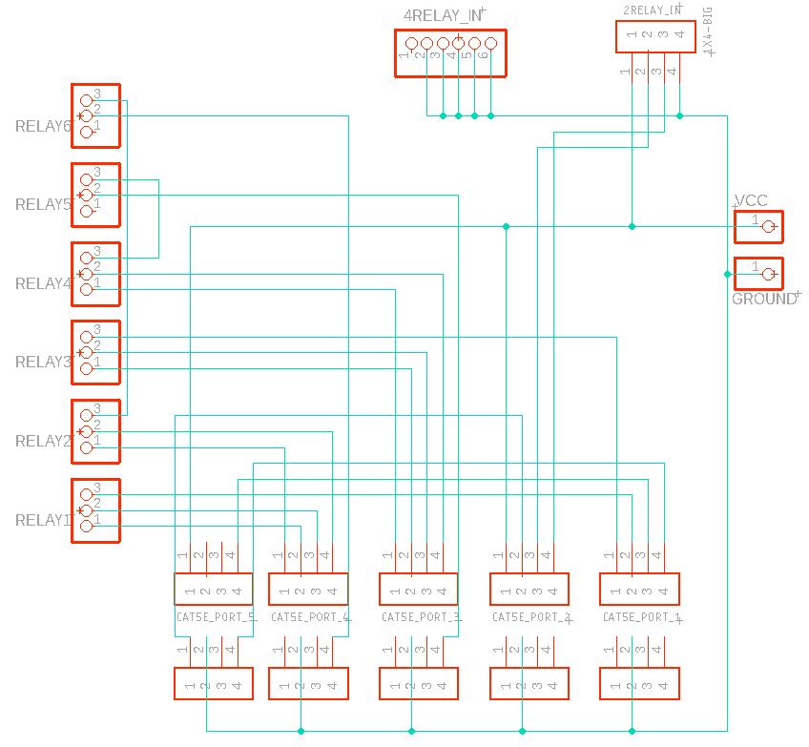

**Figure 4**: Enlarged Schematic View of Motherboard component wiring.

**2 – Arduino Board:**

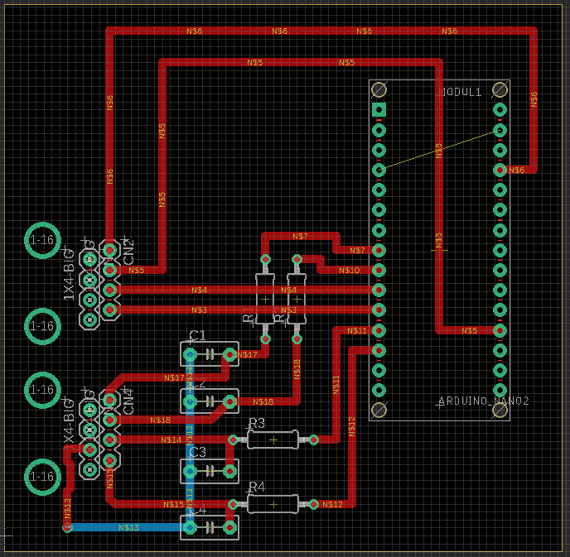

**Figure 5**: Enlarged Board View (Eagle Cad) of Arduino Board and components.

(Insert Text Here)

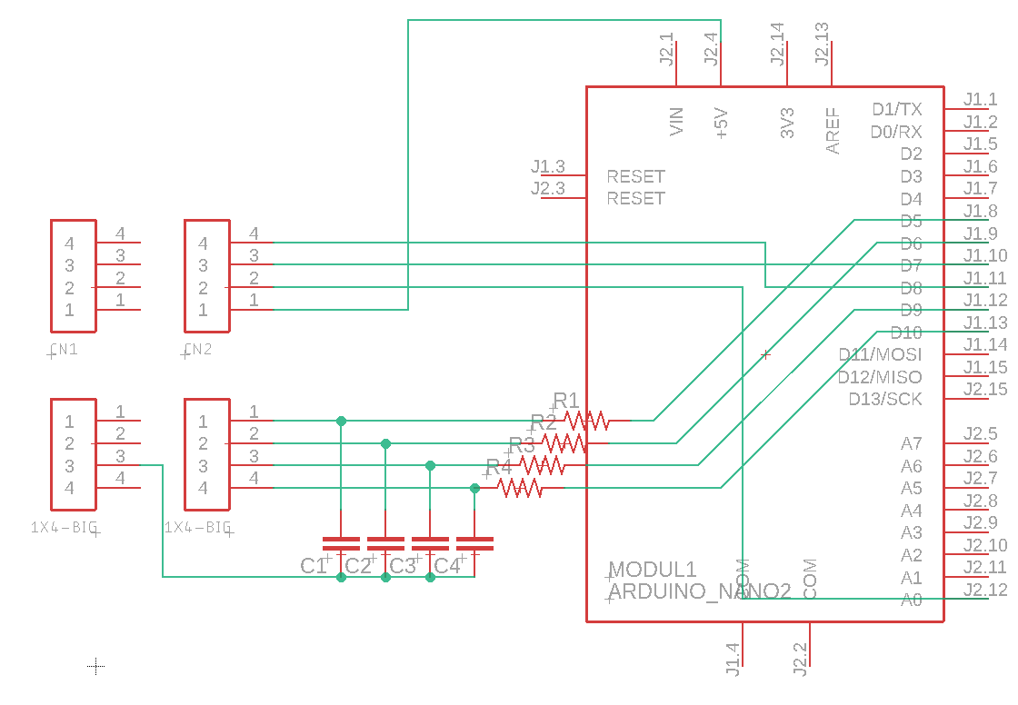**Figure 6**: Enlarged Schematic View of Arduino Board component wiring.

**3 – Steering Board:**

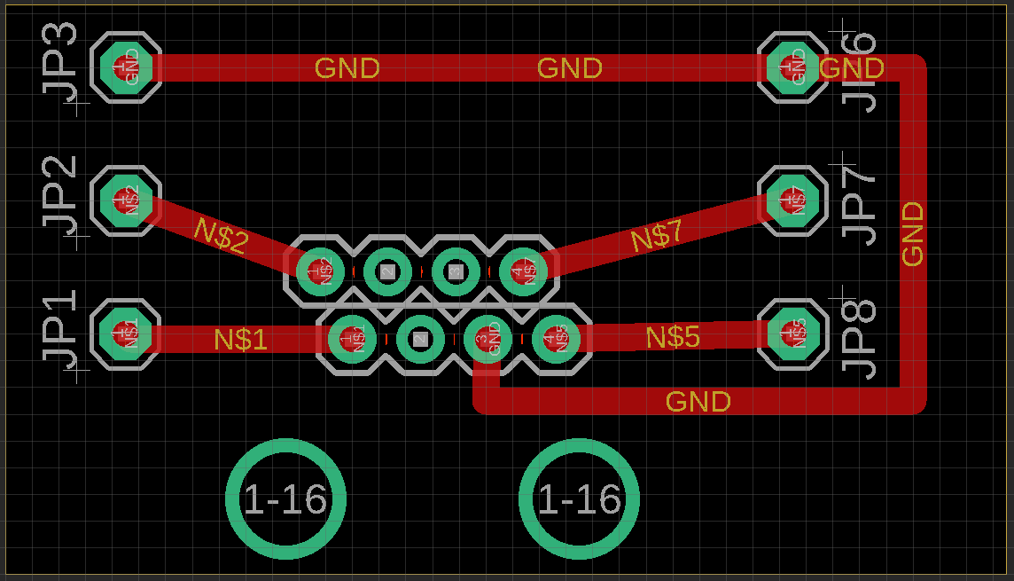

**Figure 7**: Enlarged Board View (Eagle Cad) of Steering Board and components.

The Steering board allows us to control all the directional movements within the golf cart. This board only requires a single Cat5e Module that will be placed at the center of the board where the 8 pins are found together. The pins JP6 – JP8 are connected directly to the potentiometer (see **Figure 1)**. This connection allows recovering the current steering wheel rotational position to ensure we are turning at the commanded angle when in Autonomous Mode. This potentiometer is attached to the shaft of the steering column utilizing a custom mount that we had 3D printed. The potentiometer was able to turn and read the angle with a set of gears that were attached to steering column. Pins JP1-JP3 provide access to the Steering MCU so that we may mechanically move the steering to our desired angle when moving autonomously. **Figure 8** shows the schematic view of this board.

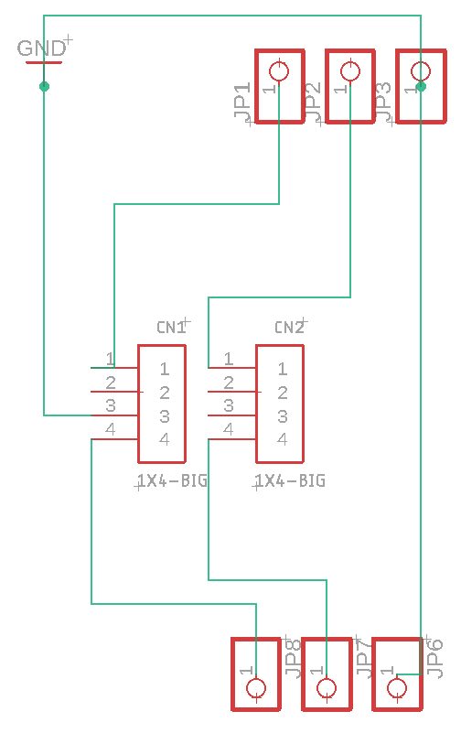

**Figure 8**: Enlarged Schematic View of Steering Board component wiring.

**4/5 – Brake/Throttle Board:**

**Figure 9**: Enlarged Board View (Eagle Cad) of Brake/Throttle Board and components.

The Brake/Throttle Board requires a single Cat5e Module placed at the center similar to the steering board. These four different sets of pins correspond to individual components found on the golf cart.

The pins on JP1, JP7, JP6, JP3, JP2, JP8 will all be a splice from the Brake Sensor and the Throttle Sensor (each on their respective boards). The pins that are directed toward the MCU here are very important as the voltage inputted into the MCU is the important thing here as this will tell the golf cart how much to accelerate.

The pins on JP4, JP5, JP9, JP10 will all be a splice from the Brake Sensor and the Throttle Sensor (on their respective boards). The switch is used to see when the Brake/Throttle pedals are actually pressed and is sent back to the Motherboard (NEED TO FIGURE THIS OUT MORE AND WRITE MORE ABOUT IT)

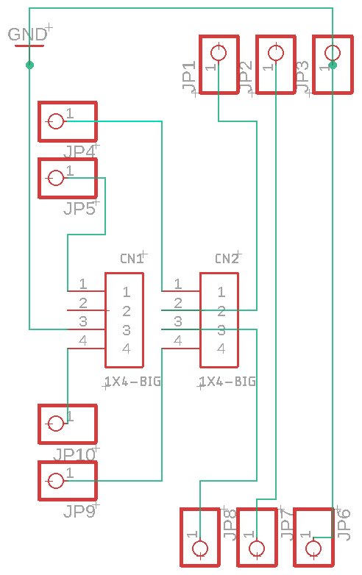

**Figure 10**: Enlarged Schematic View of Brake/Throttle Board component wiring.